Real Options Part 2
[Name]
[Institution affiliation]
[Course]
[Date]

An example of a peer-reviewed article relating to Real Options
Article Title: A Real-World Way to Manage Real Options
Authors: Tom Copeland & Peter Tufano
Link: https://hbr.org/2004/03/a-real-world-way-to-manage-real-options
Abstract
Every project in corporate growth is an option, such that management faces decisions along the way to either pulling back or pushing ahead. Yet most organizations hesitate in applying the options theory to initiatives like geographic expansion and R&D, partly because such “real” options are incredibly complicated. Most of the issues with the analysis of real-options stem from using the Black-Scholes-Merton approach that is not suitable for real possibilities.
On the contrary, the binomial models are more comfortable mathematically, and we can fiddle using a binomial approach until it reflects closely the project we want to value. Assume that an organization seeks to invest in a new plant. Using this model will require us to design an “event tree” figuring out the entire variety of possible values for the firm across the lifetime of the project- perhaps the following year, after the design stage, or upon completion. Besides, we operate backward from the completion value and factor in the significant investments in determining the current project’s cost. Such calculations offer the management with numbers for the entire possible future valuations for the option at the significant stages whereby decisions have to be established based on the project’s continuation.
Additionally, the authors touch on other real options’ critics: that gaps usually develop between theoretical & realized all types of options’ values. These gaps could be significantly the managers’ decisions about executing opportunities at the wrong time. Therefore, improving how to manage the real options requires organizations looking at the decision-triggering phases corresponding to the binomial decision tree’s nodes. As a result, the triggering stages with both inform managers about when they have to decide on exercising, and also specifying the rules regulating the exercising decisions.
Industry example demonstrating the application of this article
To illustrate how the binomial model operates, Copeland & Tufano (2004) used Copano Energy L.L.C. as an example company. Copano is an energy organization engaging in the operations of offering midstream services to the natural gas producers, involving collecting, transport, and process of natural gas (Copano Energy L.L.C. 2011). Since the firm’s inception in the year 1992, it has grown across strategic & Bolton acquisitions as well as organic growth projects. For instance, Copano had a plan to expand its DK Pipeline in 2011. The project was to cost $60 million for immediate preparation and permits, taking a year. At the end of 2011, the company was to invest $400 million in completing the design stage, with the management sure that immediately the design phase was completed, Copan will have a two-year window whereby it could invest the $800 million required for building the plant. Given that the project included a phased investment, it could be considered as a compound option because an investment of $60 million created the need to invest $400 million within a year, with the exercise of such a choice-creating the need to invest $800 million in purchasing a new asset (Copano Energy L.L.C. 2011).
At every decision stage across the new chemical plant’s life, Copano’s management wanted to understand the actions to be taken and decide on whether to remain committed to investing the entire amount required, keeping the project alive through spending fewer funds or simply pulling the plug. Therefore, the management developed a decision tree, showing how the value of the project changing over time to help them make decisions based on the best actions at the phases along the way. In developing the decision tree, Copano’s management calculated the worthiness of the plant it existed today as well as its future valuations along with the points (Copeland & Tufano, 2004). This involved developing another tree type, named the event tree-reflecting how the plant’s possible values will be defined by fluctuations in the spread between the inputs’ prices and output chemicals. The plant’s likely valuations’ calculations considered the spreading volatility. If the plant existed today, the management assumed that it would be worth $1 billion with the price spread widening increasing the value of the plant by a factor of 1.20 and also narrow the spread to decreasing its amount by a factor of 0.833. Therefore, the Event Tree shown below presented the plant’s valuation as at that day, a year after, two years after, and three years after at different points:
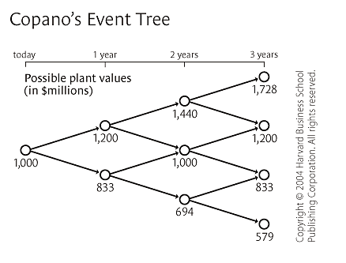
As a result, Copano’s management used the event tree’s values when calculating the decisions’ costs. The figure below shows the checkmark put by the administration concerning the choices that were to realize the maximum value of the project:
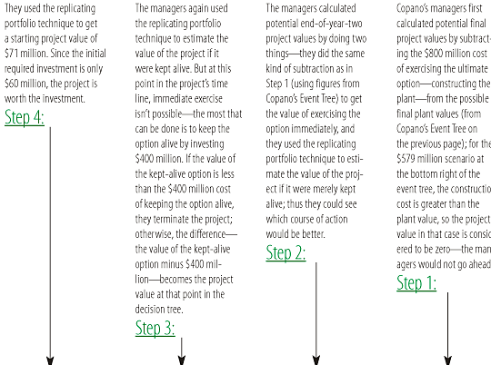
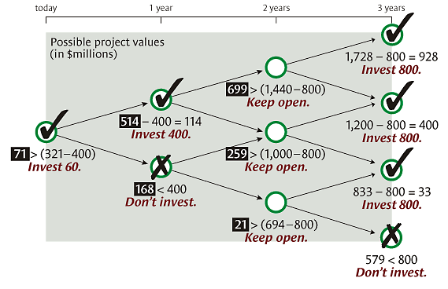
Conclusion
Copeland & Tufano (2004) show that real options are all about the possible choices or decisions made to the management about the opportunities to invest, and they involve tangible assets based on financial elements. Notably, real options include expansion, waiting, abandoning, or deferring decisions in a project, and they as well relate to organizations that make decisions that make them flexible and give them potential benefits while making future solutions.
References
Copano Energy L.L.C. (2011). Form 10-K- United States Securities & Exchange Commission. Retrieved from: https://www.sec.gov/Archives/edgar/data/1297067/000119312512089552/d270993d10k.htm#tx270993_1
Copeland, T., & Tufano, P. (January 01, 2004). A real-world way to manage real options. Harvard Business Review, 82, 3, 90-9. Retrieved from: https://hbr.org/2004/03/a-real-world-way-to-manage-real-options
NB: Make sure you delete this part before submission please it is the safest way I though to tell you my thoughts: The site charges much but we can work outside and make payments through PayPal if you like my services after you submit this paper and get your grade. Kindly contact me via what sap using this number (+254 715 289 661) or by mail (sdavy34@gmail.com). I hope this finds you well my friend. Thank you and I will be waiting to hear from you.

